MODULE 4 – INTRODUCTION TO DBMS

LAB EXERCISES

5. ALTER Command
Lab 1.
Modify the courses table by adding a column course_duration using the ALTER command.
Ans.
1. ALTER TABLE courses add course_duration varchar(255)
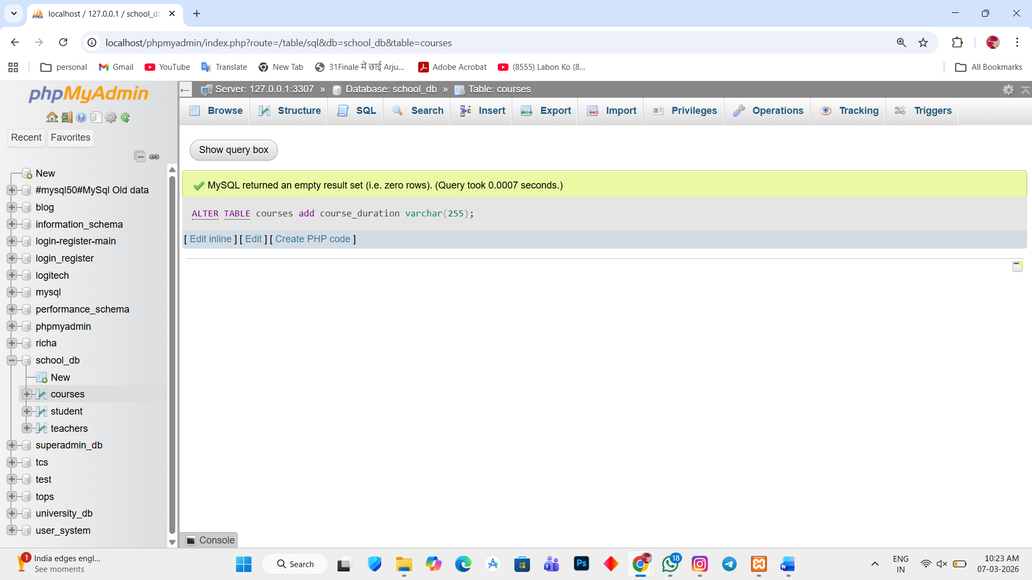

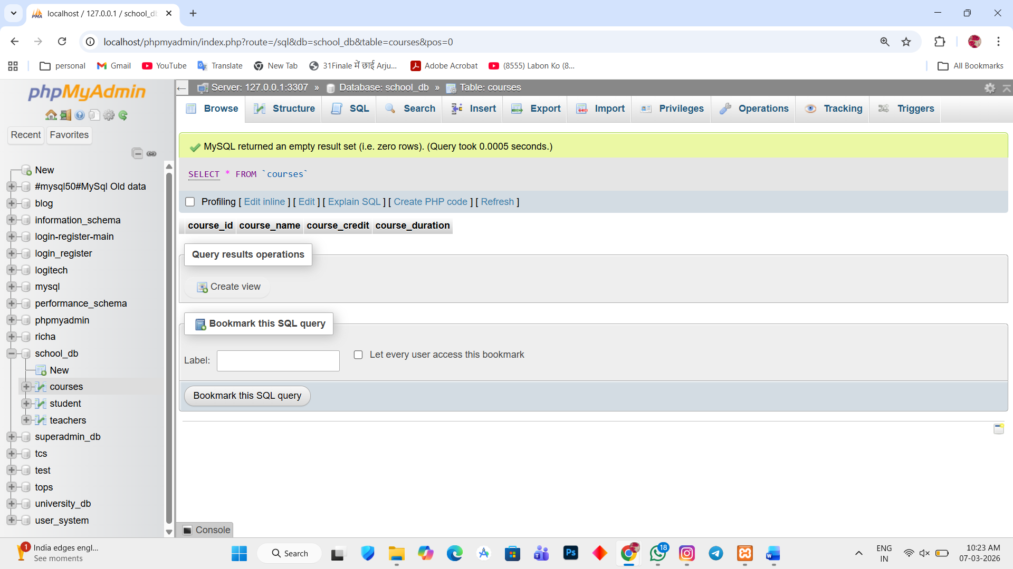

Lab 2.
Drop the course_credits column from the courses table.
Ans.
1. ALTER TABLE courses DROP course_credit
